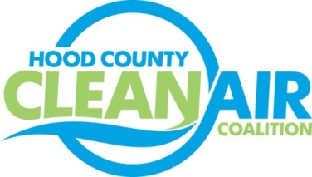
Meeting: Thursday, October 5, 2017
Neely House
304 East Rucker Street, Granbury, Texas 76048
8:30-10:00 a.m.

Agenda

- Call Meeting to Order
- EPA Updates – Randy Pitre, EPA
- Local Updates – Michelle McKenzie
  - Review of August and September Meeting Summaries
  - Reports
    - September Ozone Update
    - Air North Texas Conference Call
  - Review of Projects
    - Monthly Budget Review for July and August
    - Status of Projects FY 16/17
  - Loss of Rider 7 Funding
- Regional Updates – Michelle McKenzie
  - Clean Vehicle Solutions for School Districts Webinar www.dfwcleancities.org/resources
  - FREE Solar Trainings for Cities at Irving West Library, Register at www.gosolartexas.org/events
    - Permitting, Inspection, and Zoning, October 11
    - Fire and Safety Training, October 12
  - Funding Highlights
    - TERP Alternative Fuel Fueling Stations, www.terpgrants.org
    - Fleets for the Future, www.fleetsforthefuture.org
    - Other Funding Opportunities, www.nctcog.org/aqfunding
- Other Discussion
- Adjourn

